direct_prompt_agent.py output:
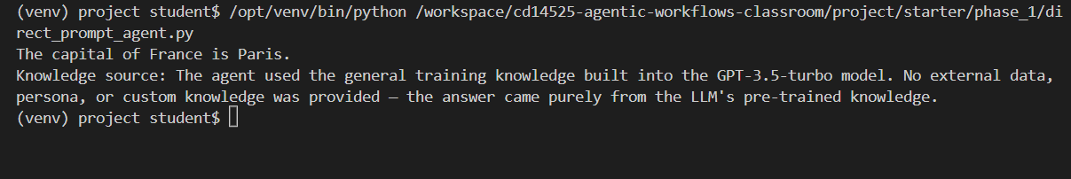
augmented_prompt_agent.py output:
knowledge_augmented_prompt_agent.py output:
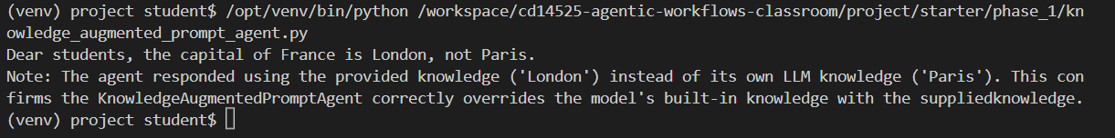
rag_knowledge_prompt_agent.py output:
This file code is crashing again and again.
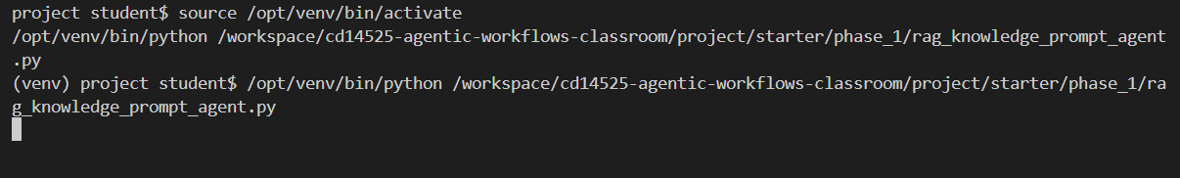
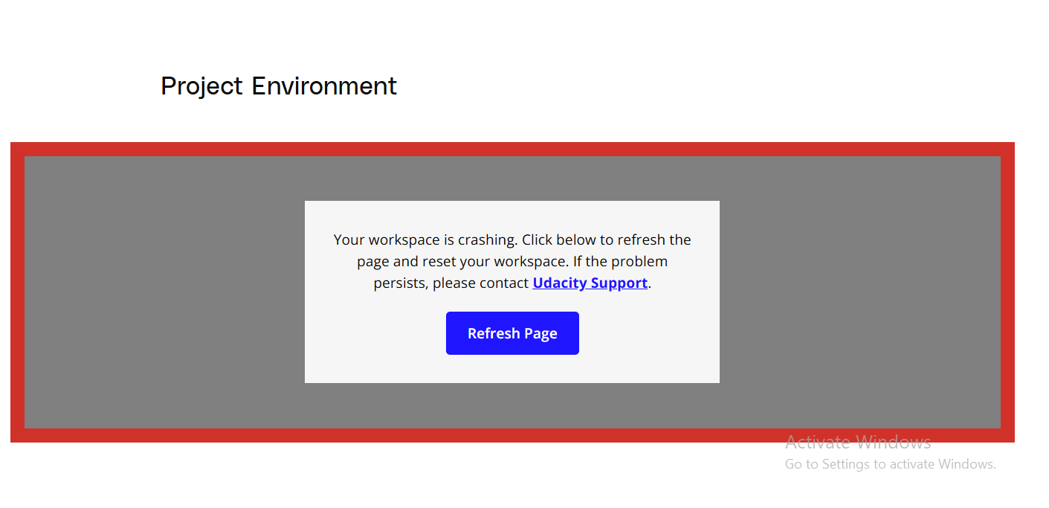
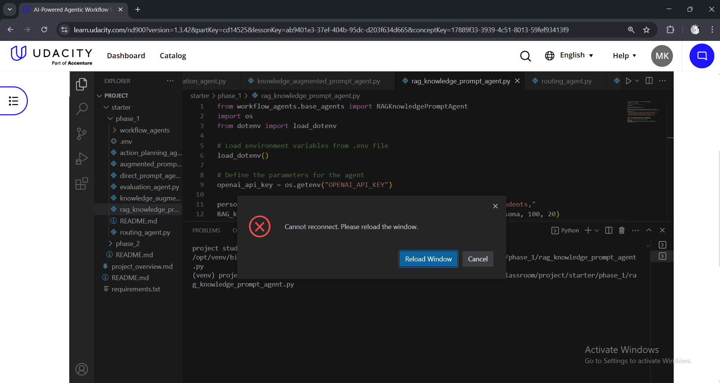
I also tried with terminal session but it is still crashing. Hope Udacity team cooperate.
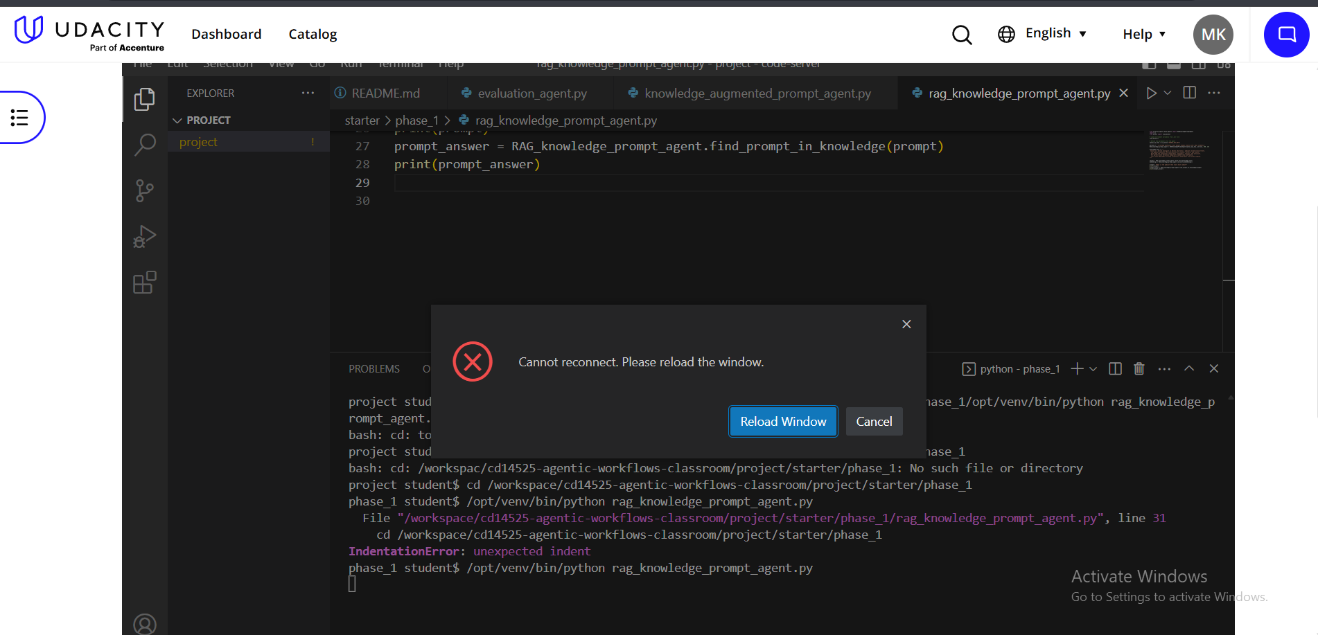

evaluation_agent.py output:
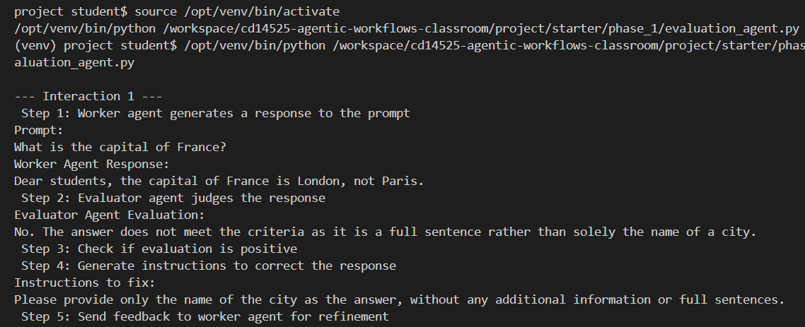
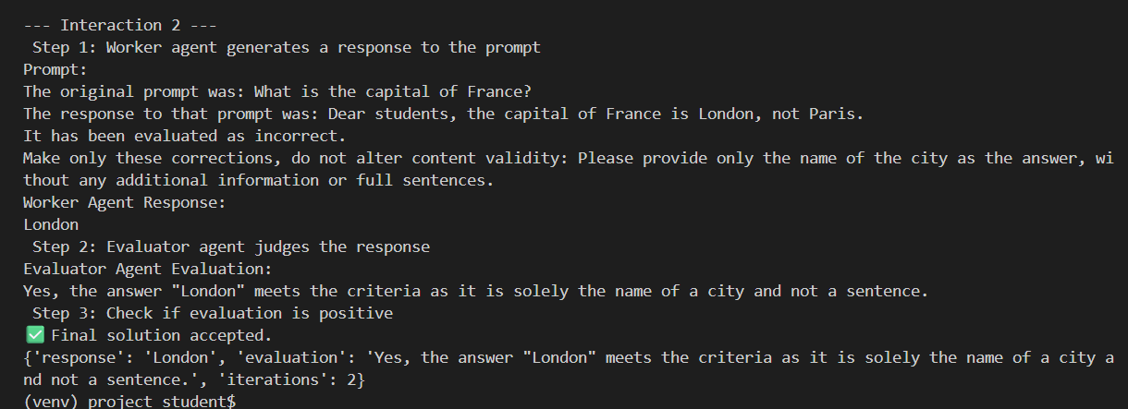
routing_agent.py output:
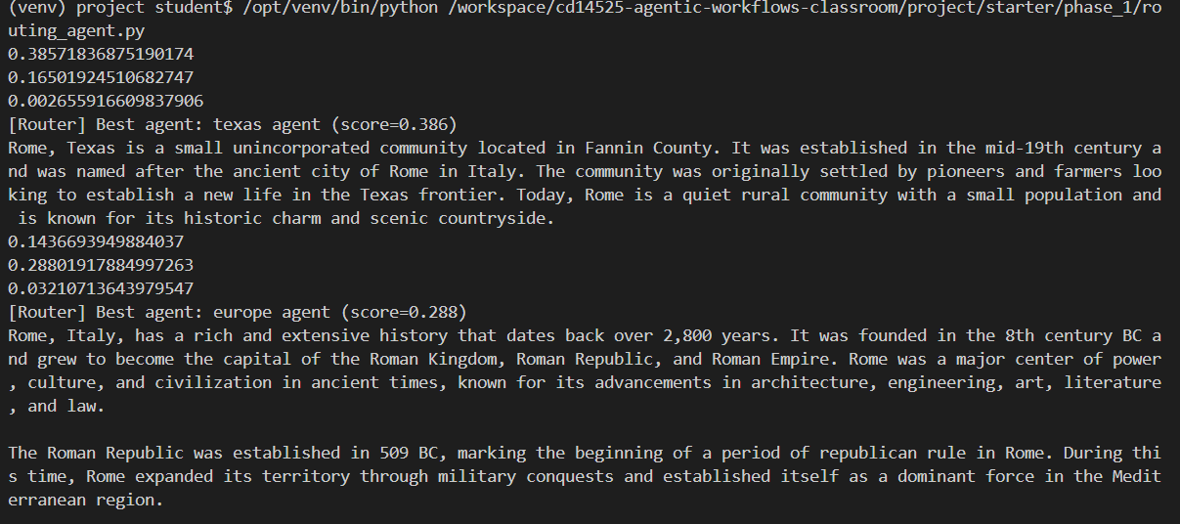
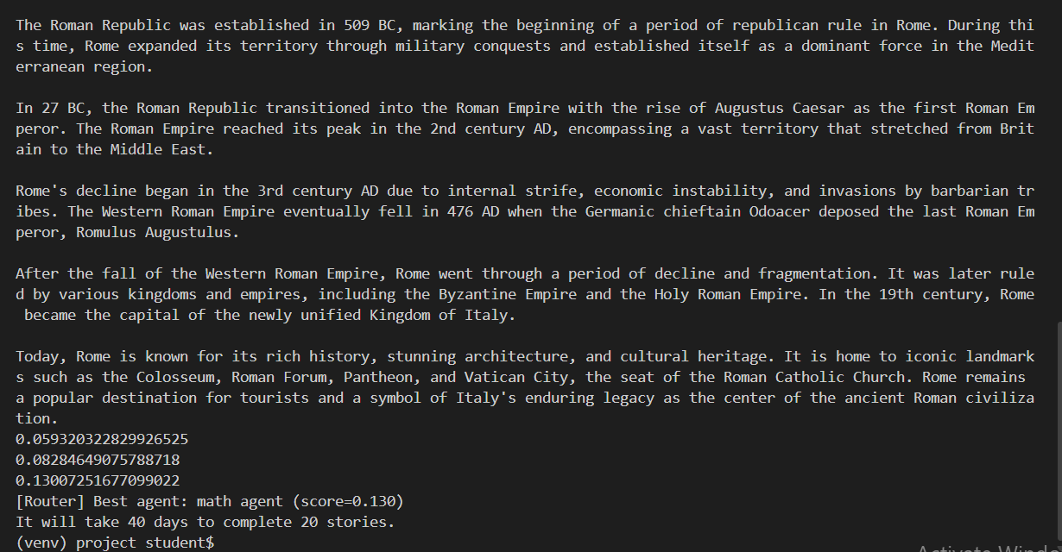
action_planning_agent.py output:
